1) 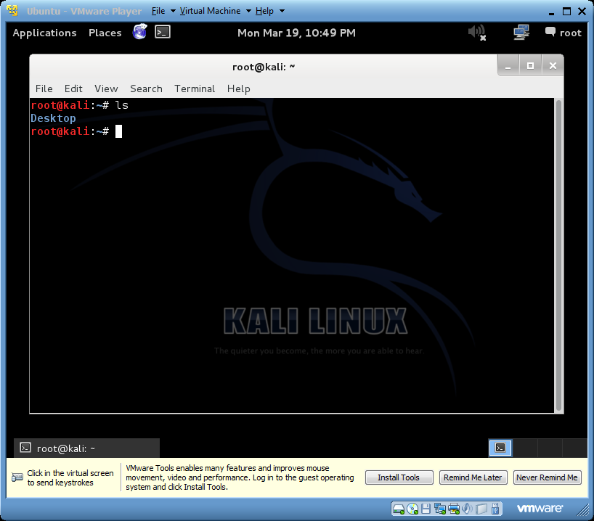

* “ls” command means it list information about files.

2) 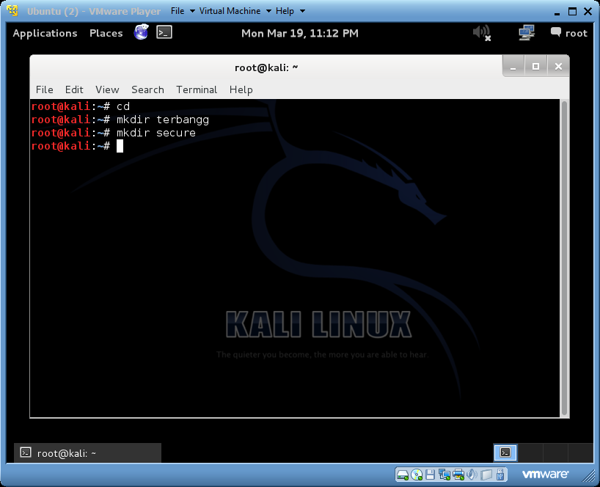 🡪 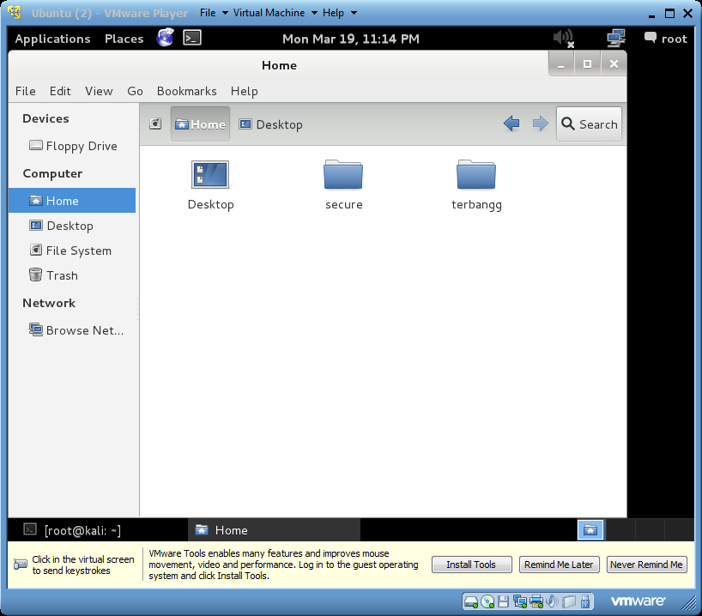

-“mkdir” command means creating new folders. Like in the example, it creates the file secure and terbangg.

3) 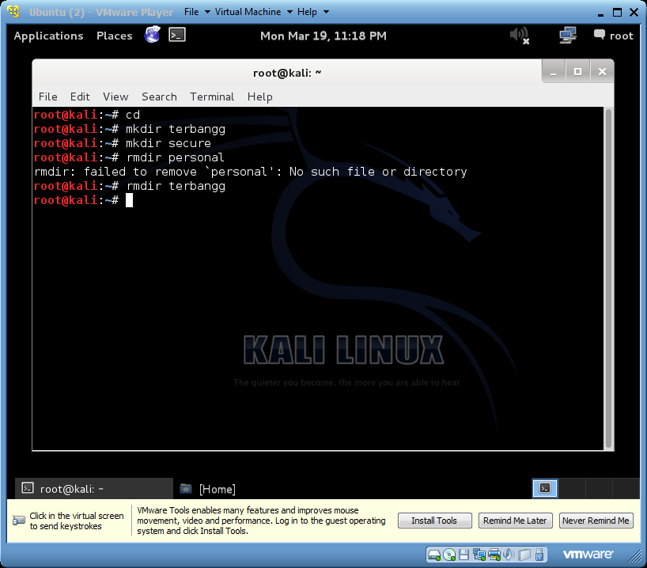 🡪 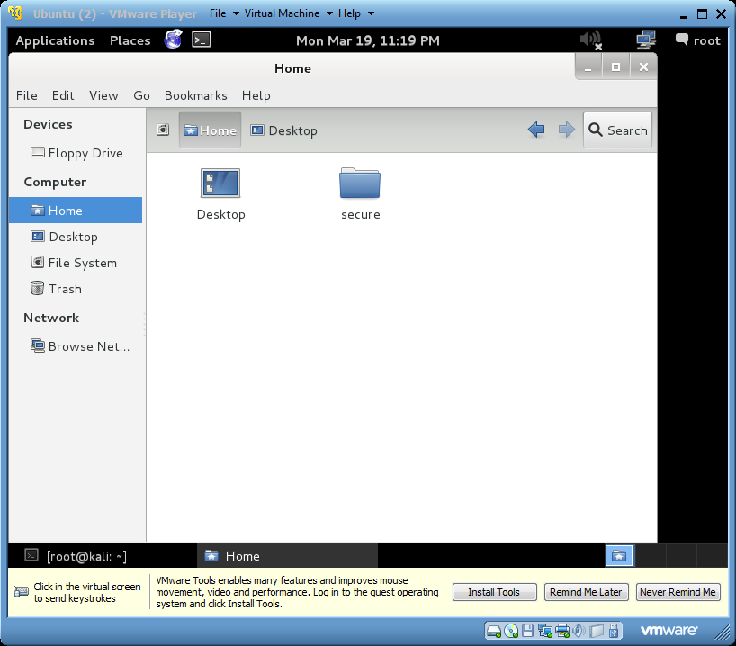

-“rmdir” command is to remove folders or directory. The terbangg folder has been removed.

4) 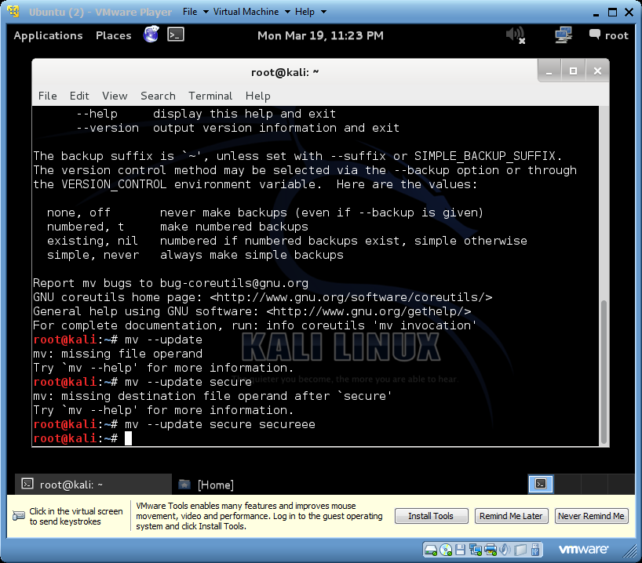 🡪 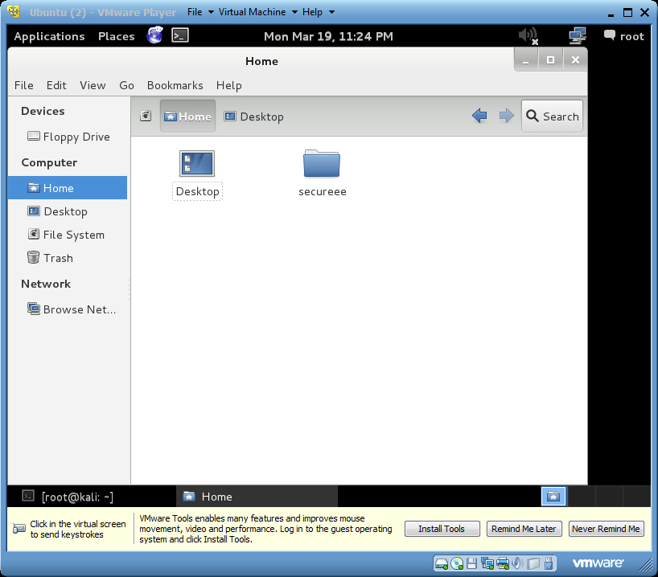

-“mv” means to move or rename files. In the example, it renames the file ‘secure’ to ‘secureee’.

5) 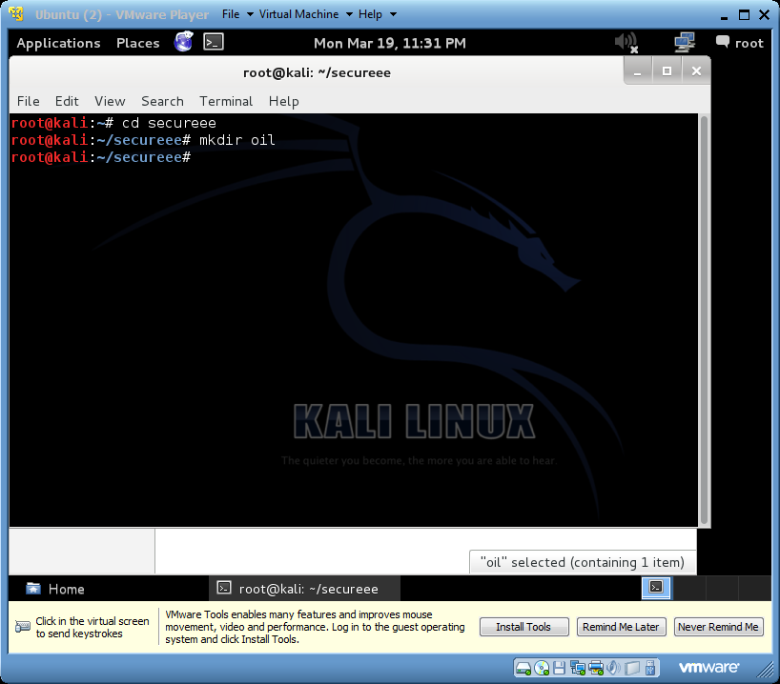 🡪 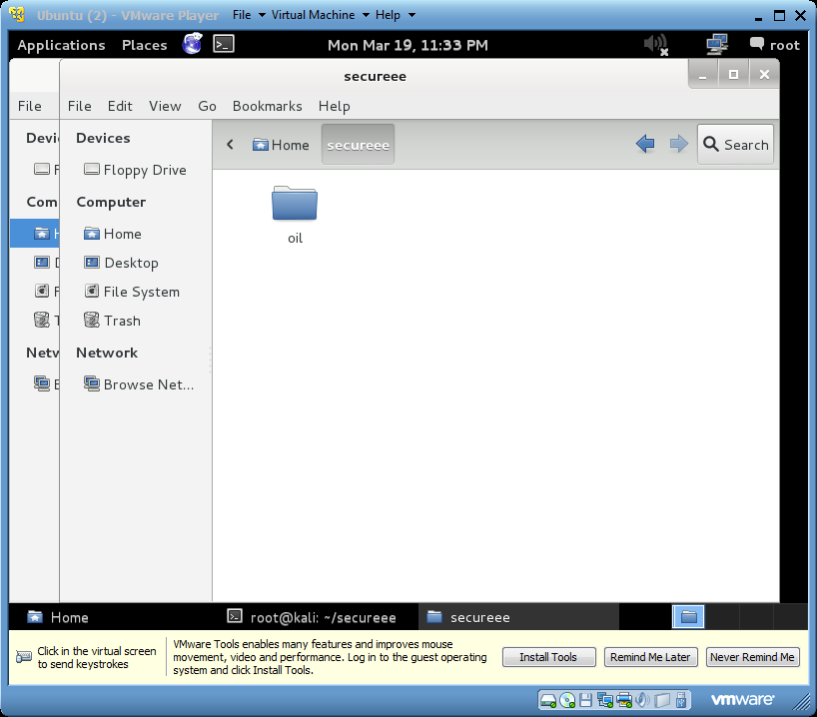

-“cd” means to change directory

6) uname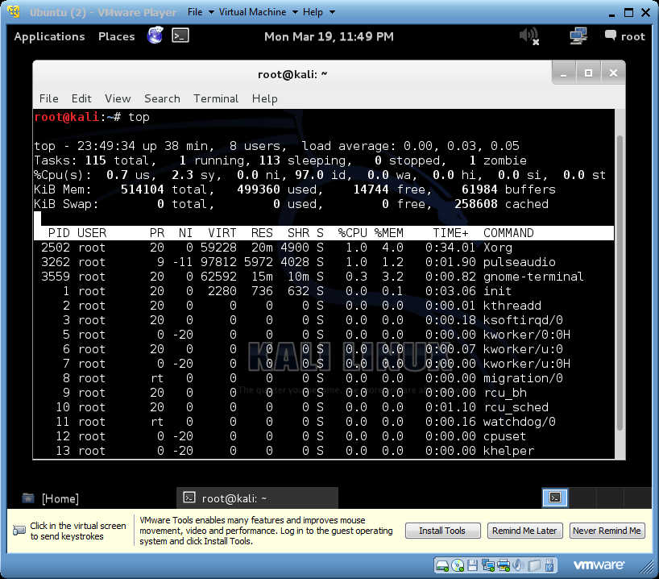

-“top” command is to list the processes running on the system.

7) 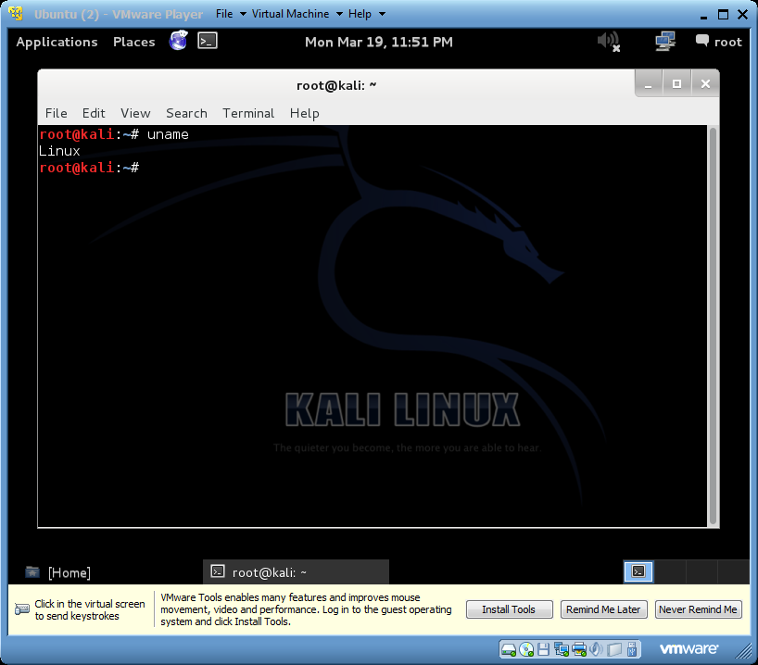

- “uname” command is to print the system information.

8) 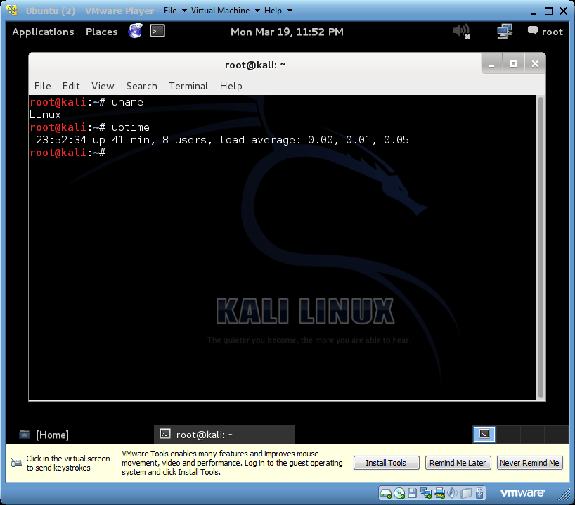

-“uptime” command is to show the uptime which means the clock reading, in minutes,seconds and nanoseconds. It also show the number os users and load average.

9) 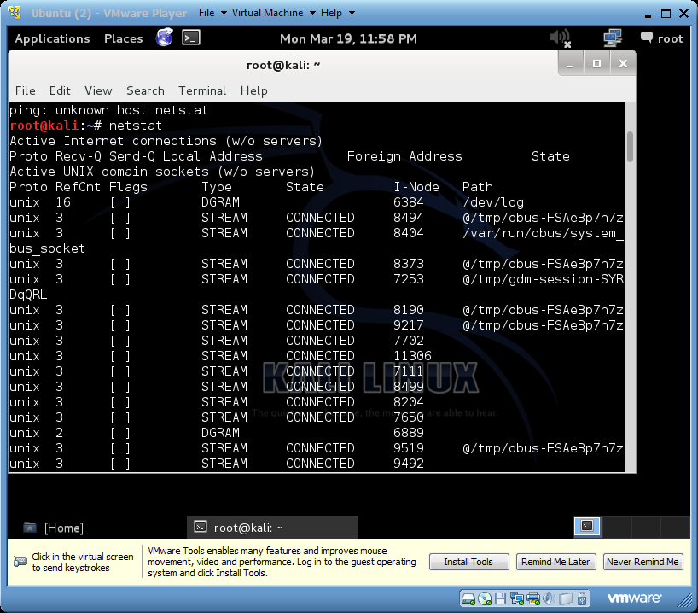

- “netstat” command is to show the networking information on the system.

10) 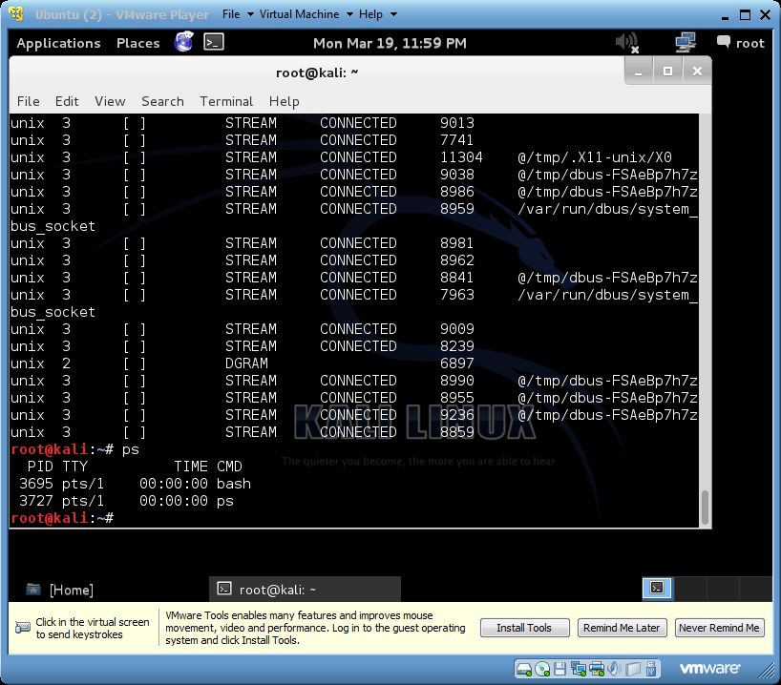

-“ps” command is to show the process status.

11) 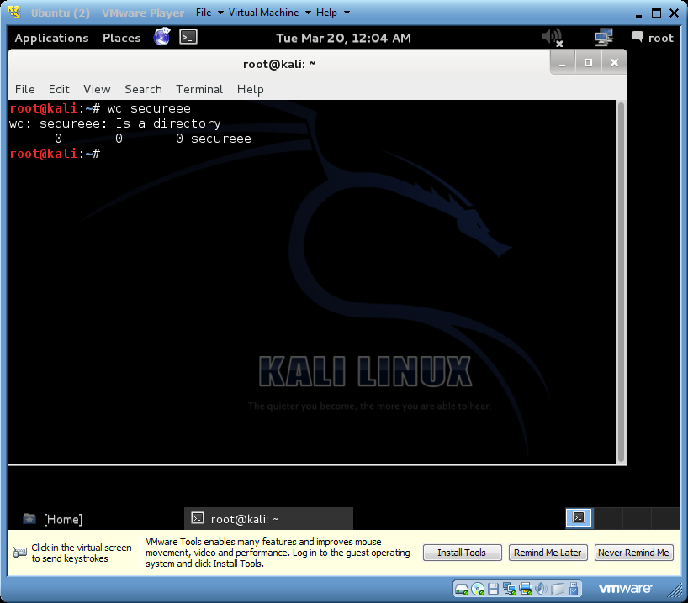

-“wc” command is to print out the file that has been chosen in byte, word and line counts.

12) 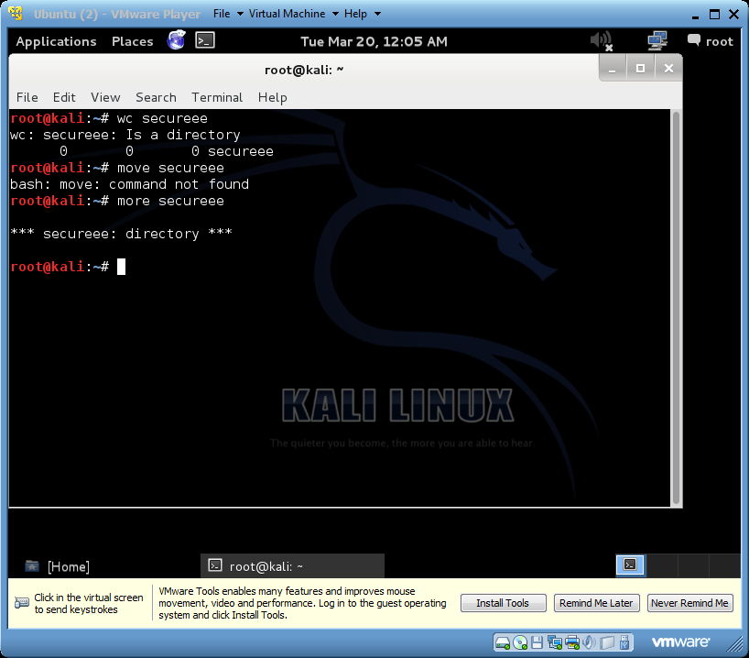

-“more” command is to display the output in one screen at a time.

13) 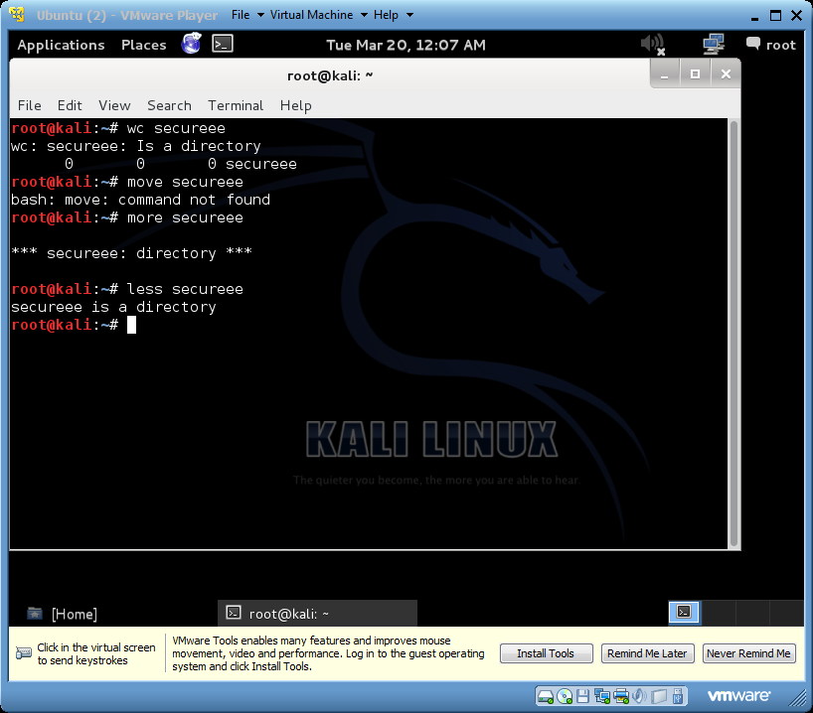

-“less” is a command on dosplaying output one screen at a time.

14) 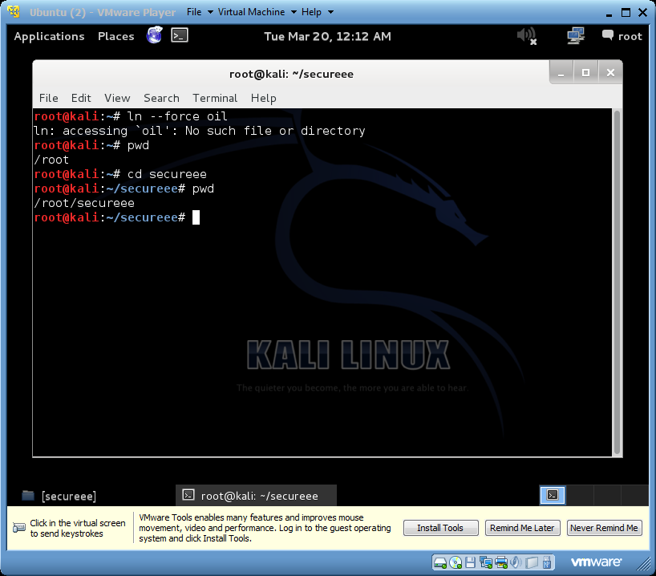

-“pwd” command is to print the working directory involves at the time.

15) 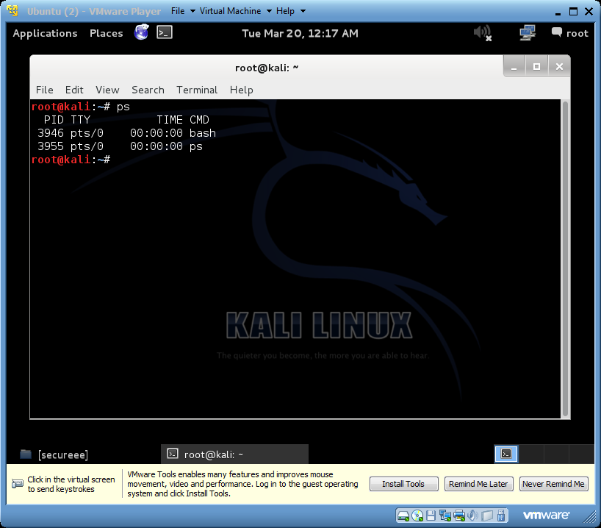

-“ps” command is to check on the process status.

16) 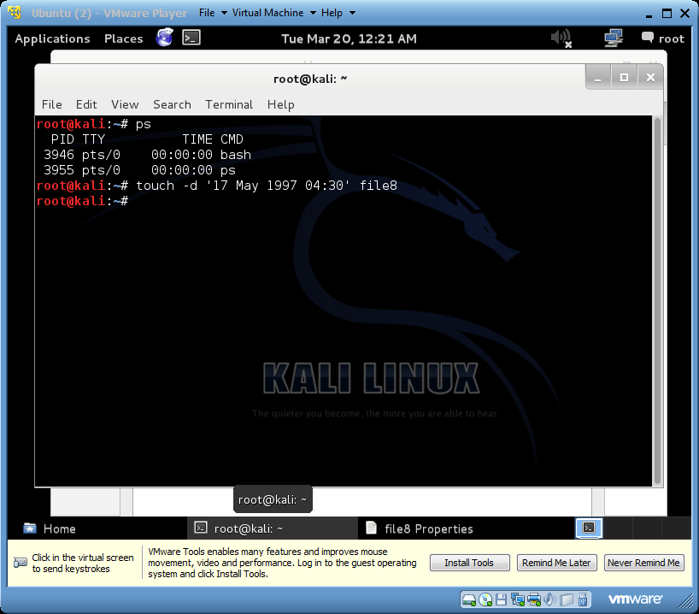 🡪

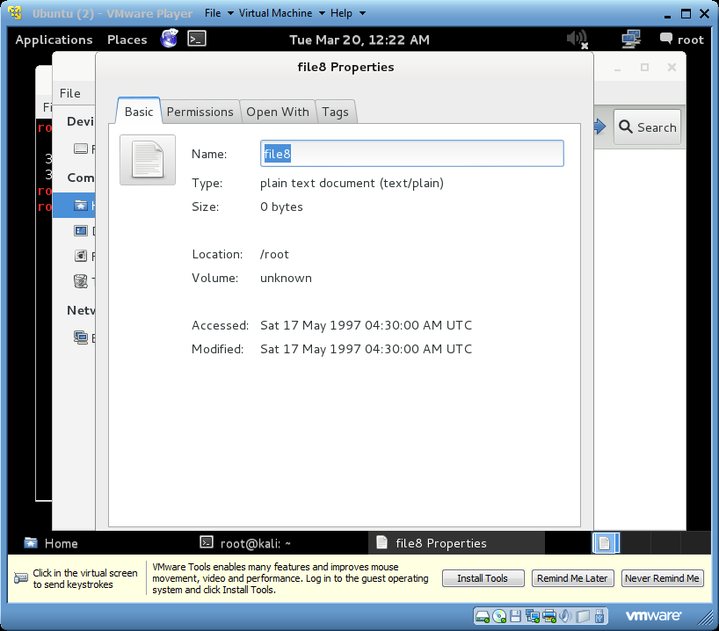

-“touch” command is to change the file timestamps. The –d optoins allow user to add a specific last access time.

17) 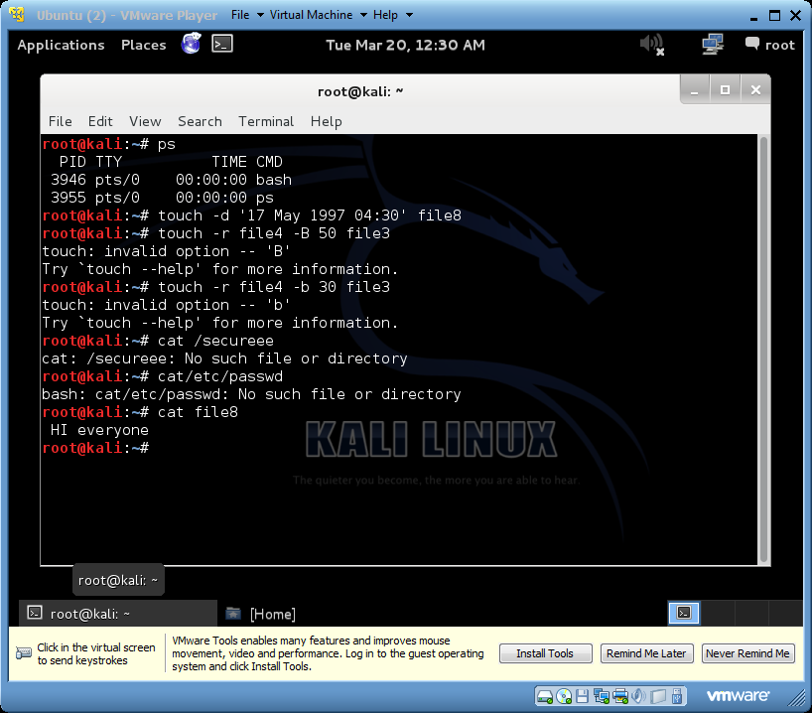

-“cat file8” command is to display the contents of file8 file in terminal.

18) 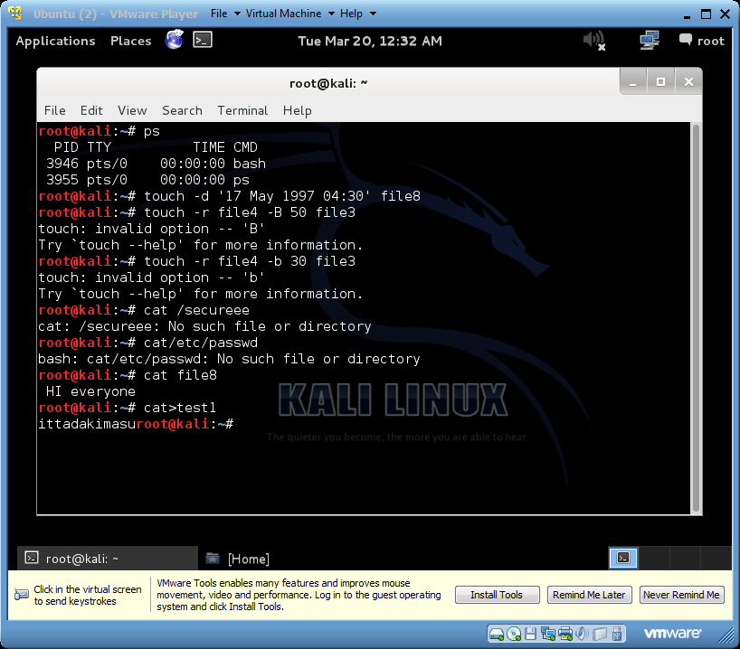 🡪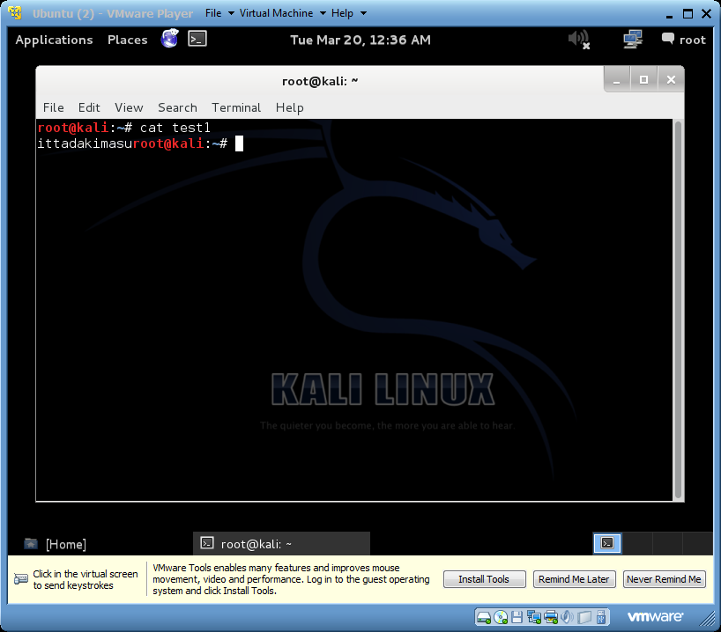

-“cat>test1” command is to create a file called test1 file with ‘ittadakimasu’ inputs from the user. You can see content of file with the command as of above.

19) 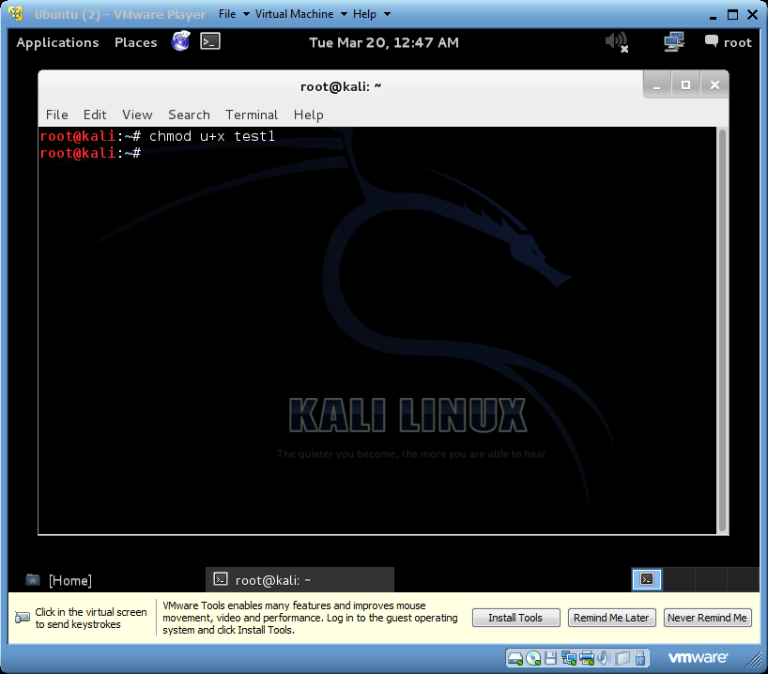 🡪 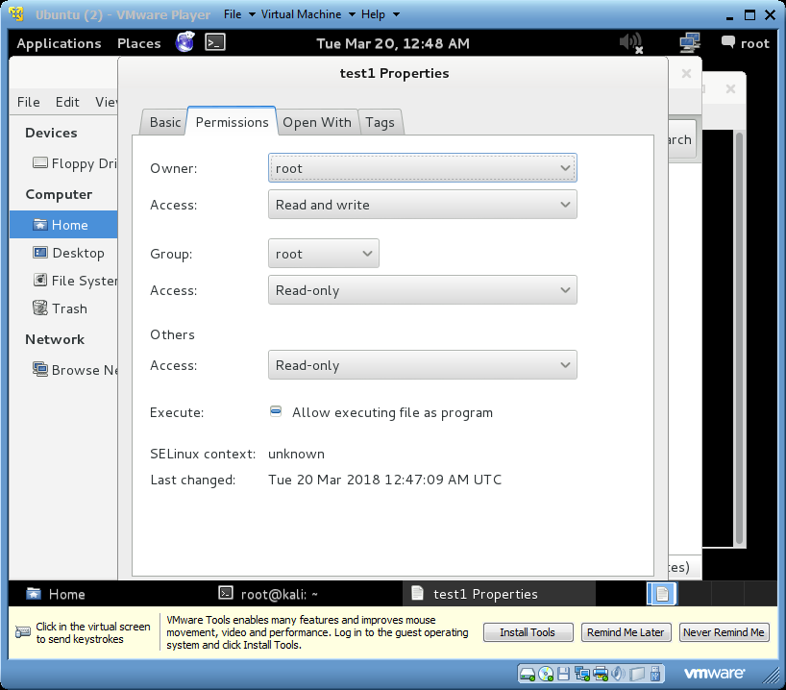

* “chmod u+x test1” command is to add single permission to a file/directory. Changing permission to a single set. + symbol means adding permission.

20) 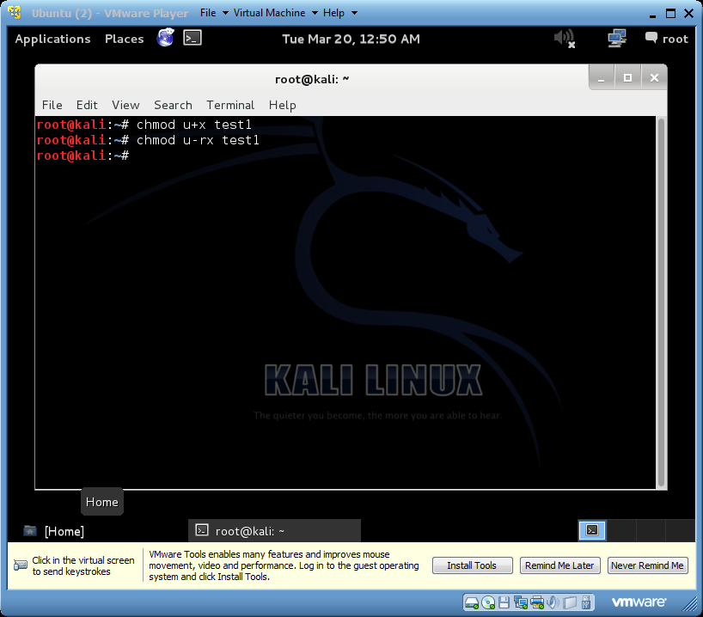 🡪 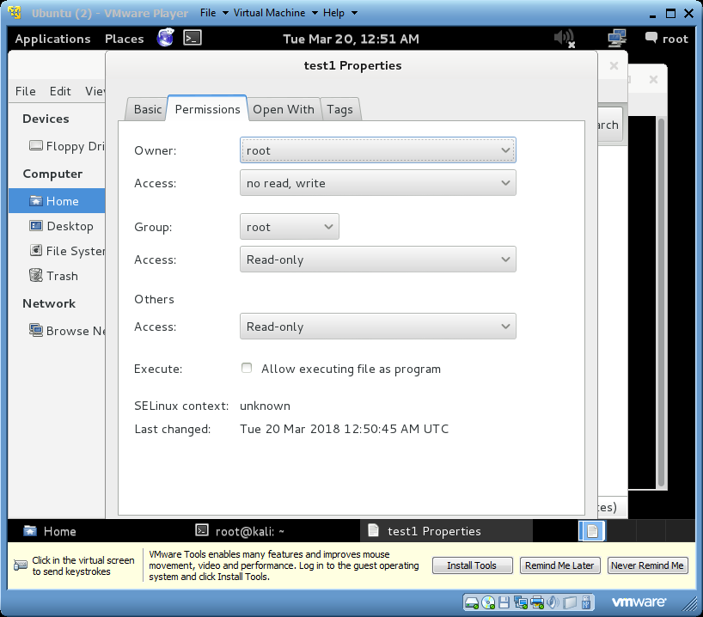

-“chmod u-rx test1” command is to remove permission from a file/directory. U means user, r means read and x means permission to execute.

21) 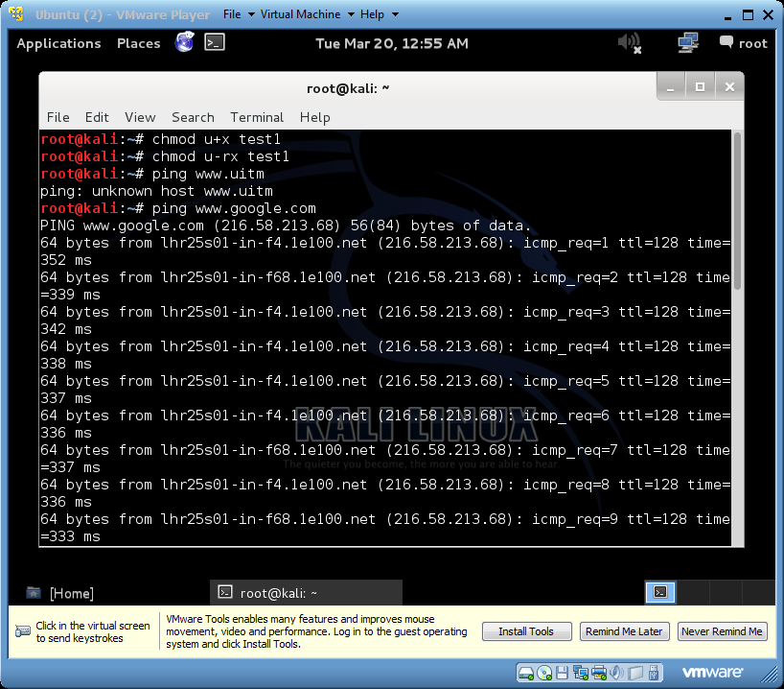

-“ping” command is to test a network connection.

22) 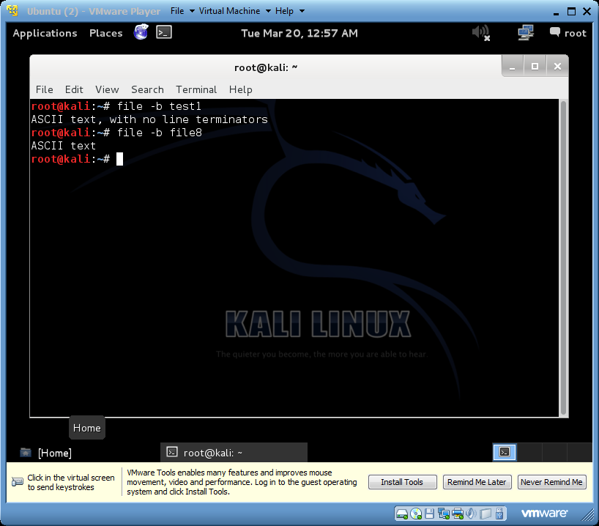

-“file ” command with “-b” option is to show just the file type.

23) 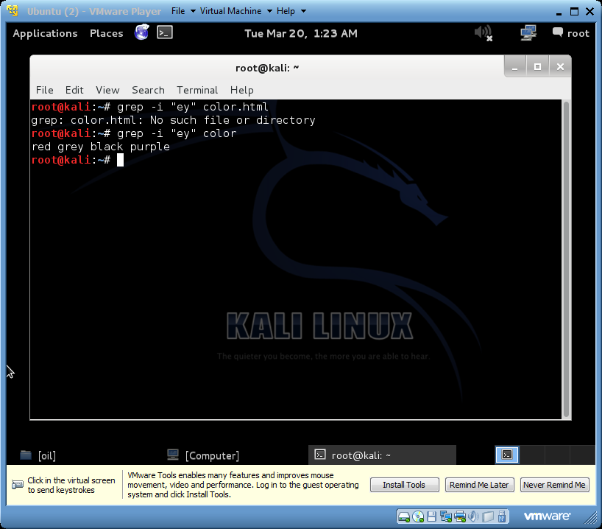

-“grep” command with “-i” option is to force grep to ignore word case. It is also to search for a word.

24) 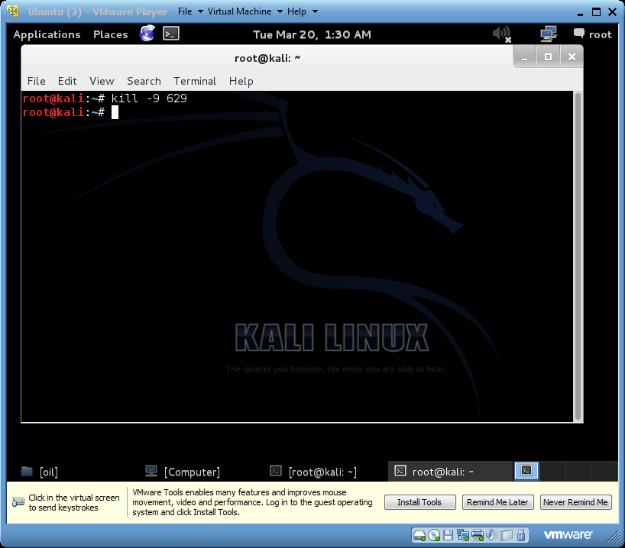

-“kill” with “-9” option is to kill signal with SIGKILL. It would guarantee to kill the process number 629.

25) 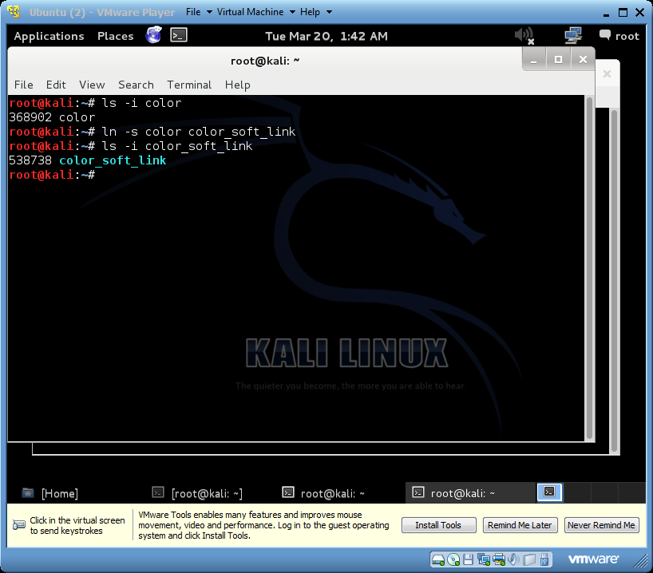 🡪 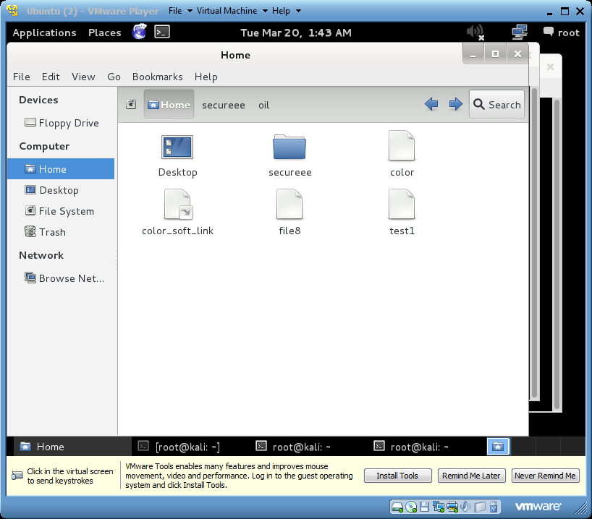

-“ls” with “-s” option command is to create soft/symbolic link. The color_soft_link file is a soft/symbolic link, as confirmed by its sky blue text color.